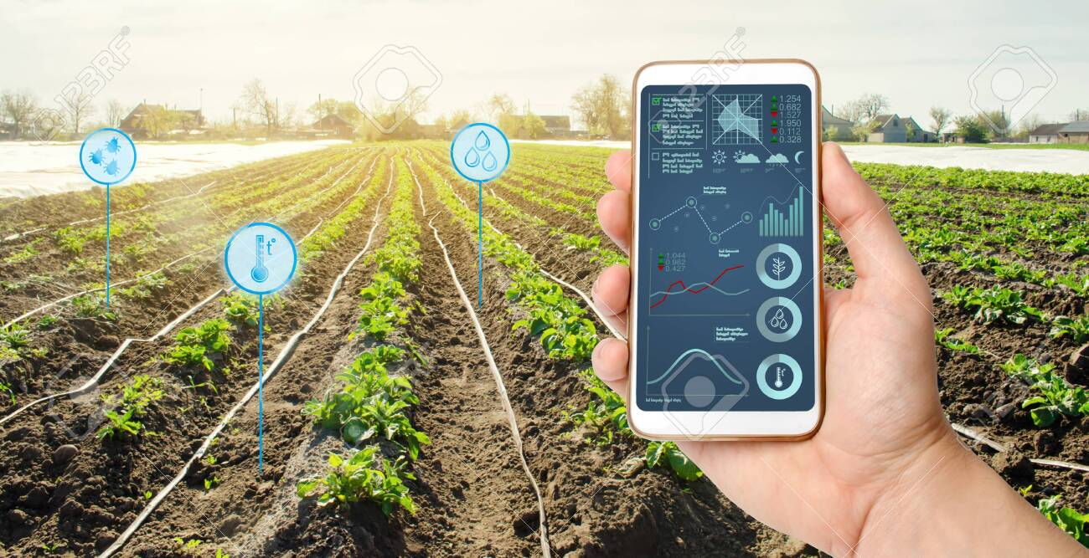

|  |
| --- |
| Project one  proposal |
|  |
| Provide by : Nouf Alswuida |

* What is the framing question of your analysis, or the purpose of the model/system you plan to build?

When we build smart products in the field of the Internet of Things, we need a certain prediction to program the product to adapt to this prediction, meaning when I want to build smart solutions for farming in smart farms, I must have a forecast for the weather and rain that may fall at that time of the year Water consumption should be reduced from the usual percentage in the pump in order to avoid the excess water percentage on crops and plants, which may become adverse results on productivity.

* Who benefits from exploring this question or building this model/system?

Producer: IoT engineer

Client: farmer

Data Description:

* What dataset(s) do you plan to use, and how will you obtain the data?

I'm going to use the weather dataset.

By searching the internet for the most suitable dataset that helps my goal.

* What is an individual sample/unit of analysis in this project?What characteristics/features do you expect to work with?

Temperature, humidity, rainfall.

* If modeling, what will you predict as your target?

Determine the days of the year when the temperature and humidity are appropriate,

and there is a high probability of rain.

Tools:

* How do you intend to meet the tools requirement of the project?

Anaconda Navigator – Jupyter.

* Are you planning in advance to need or use additional tools beyond those required?

In this time No.